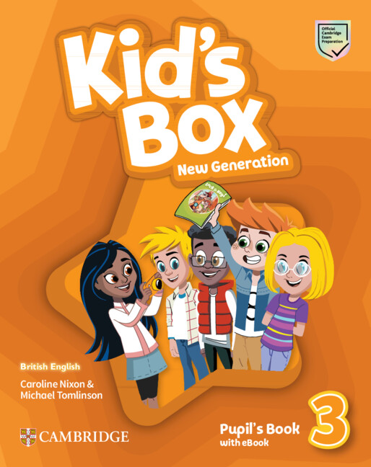

Grammar Supplements
09.04.2025 By Damien Arthur, Director of Studies, ARTHUR’S ACADEMY

Overview
The Grammer supplementary material is focussed on the grammar points of each unit. I have prepared these because as Kid’s box series progresses the vocabulary and grammar expands but if students are not receiving a solid foundation in grammar from their regular school, that needs to be reinforced so this helps to prepare them for the unit and pre-teach the necessary structures so that they can progress with the vocabulary and different scenarios.

Goals
- Revise grammar they have learned in Kid’s box 2 and are seeing again in these units
- Provide structured exercises to allow the students to use English sentences correctly.

Milestones

Grammar
English tests at school or Eiken tests often test grammar and vocabulary which are covered in Kid’s box 3 but they are taught implicitly in the text, these exercises teach them explicitly and directly.

Knowledge and Familiarity
By reinforced learning they learn test taking techniques on a regular basis and they learn the grammar structures allowing them to know the first person, I am, second person You are and third person S/He is and how the grammar changes with this.
This pattern means they are more familiar with and able to talk about themselves, each other and the third person so they can use English with more confidence.

Unit 1 – Present Simple vs. Present Continuous

Instructions (ひらがな)
つぎの ぶんを よんで、（ ）に あう ことばを いれてね。

Exercise
- She always ______ (play) the piano after school.
- Look! He ______ (run) in the park now.
- They ______ (like) pizza very much.
- I ______ (watch) TV at the moment.
- My father usually ______ (cook) dinner on Sundays.

Unit 2 – There is / There are

Instructions (ひらがな)
しゃしんを そうぞうして、（ ）に あう ことばを かいてね。

Exercise
- ______ a dog in the garden. (is / are)
- ______ two books on the table. (is / are)
- ______ some milk in the fridge. (is / are)
- ______ five chairs in the classroom. (is / are)
- ______ an apple on the desk. (is / are)

Unit 3 – Past Simple of “to be”

Instructions (ひらがな)
きのうのことを かんがえて、（ ）に あう ことばを いれてね。

Exercise
- I ______ (was / were) at the park yesterday.
- They ______ (was / were) very happy last week.
- He ______ (was / were) sick on Monday.
- We ______ (was / were) in Tokyo last summer.
- She ______ (was / were) at home last night.

Unit 4 – Past Simple (Regular Verbs)

Instructions (ひらがな)
きのうや せんしゅうのことを かんがえて、（ ）に ただしい ことばを いれてね。

Exercise
- I ______ (play) football yesterday.
- She ______ (watch) a movie last night.
- We ______ (visit) our grandparents last weekend.
- They ______ (clean) their rooms in the morning.
- He ______ (cook) pasta for dinner.
- My mother ______ (work) late on Monday.
- The children ______ (walk) to school yesterday.
- We ______ (enjoy) the party a lot.
- I ______ (start) my homework after dinner.
- They ______ (finish) the game at 8 o’clock.

Unit 5 – Past Simple (Irregular Verbs)

Instructions (ひらがな)
ことばを よくみて、ふきゅうどうし（go, eat, see, have など）を ただしい かたちに かえて（ ）に いれてね。

Exercise
- I ______ (go) to the zoo last Sunday.
- She ______ (eat) sushi for lunch.
- We ______ (have) a big test last week.
- He ______ (see) his friends at the park.
- They ______ (make) a cake for their mother.
- My father ______ (buy) a new car.
- The children ______ (find) a lost puppy.
- I ______ (read) a funny book yesterday.
- She ______ (write) a letter to her cousin.
- We ______ (drink) orange juice in the morning.

Unit 6 – Comparative and Superlative Adjectives

Instructions (ひらがな)
ふたつのものや ひとを くらべて、（ ）に ただしい かたち（bigger / the biggest など）を いれてね。

Exercise
- My house is ______ (big) than yours.
- This test is ______ (easy) than the last one.
- She is the ______ (tall) girl in the class.
- Today is ______ (hot) than yesterday.
- This book is ______ (interesting) than that one.
- He is the ______ (good) football player in the school.
- My bike is ______ (new) than my brother’s.
- This problem is the ______ (difficult) in the homework.
- The elephant is ______ (large) than the lion.
- That movie was the ______ (funny) I have ever seen.

Unit 7 – Future with will

Instructions (ひらがな)
みらいのことを かんがえて、（ ）に will をつかって ただしい ぶんを つくってね。

Exercise
- I ______ (help) you with your homework.
- She ______ (visit) her grandmother tomorrow.
- They ______ (play) football next weekend.
- We ______ (eat) pizza for dinner tonight.
- He ______ (be) late for school.
- It ______ (rain) tomorrow.
- I ______ (call) you after school.
- My friends ______ (come) to my party.
- She ______ (read) a new book next week.
- We ______ (travel) to Kyoto next summer.

Unit 8 – Going to (Future Plans)

Instructions (ひらがな)
よていのことを かんがえて、（ ）に am / is / are going to をつかって ただしい ぶんを つくってね。

Exercise
- I ______ (visit) the library this afternoon.
- She ______ (buy) a new dress.
- We ______ (watch) TV after dinner.
- They ______ (play) basketball in the park.
- He ______ (do) his homework soon.
- My parents ______ (cook) dinner tonight.
- The dog ______ (sleep) on the sofa.
- I ______ (draw) a picture for my teacher.
- She ______ (write) an email to her cousin.
- We ______ (travel) to Thailand this winter.

Unit 9 – Have to / Don’t have to (Obligation)

Instructions (ひらがな)
するひつようが あることと、しなくてもいいことを かんがえて、（ ）に have to または don’t have to をいれてね。

Exercise
- I ______ wear a uniform at school.
- She ______ do her homework before dinner.
- We ______ clean our rooms every Saturday.
- They ______ wake up early on Sundays.
- He ______ study for the big test.
- You ______ be quiet in the library.
- My brother ______ wash the dishes (it’s my job).
- We ______ listen to the teacher.
- She ______ help her mother in the kitchen.
- I ______ go to bed late on weekdays.

Unit 10 – Question Words (Who, What, Where, When, Why, How)

Instructions (ひらがな)
しつもんのことば（Who, What, Where, When, Why, How）をつかって、（ ）に ただしい ことばを いれてね。

Exercise
- ______ is your best friend?
- ______ are you going after school?
- ______ is making that noise?
- ______ is your favorite subject?
- ______ are you sad?
- ______ is sitting next to you?
- ______ do you play with at the park?
- ______ is coming to the party?
- ______ do you go to school? (By bus / On foot)
- ______ is your teacher’s name?

